NUMERICAL TECHINQUE
A) Write the general formula for simpson’s 1/3 rule.
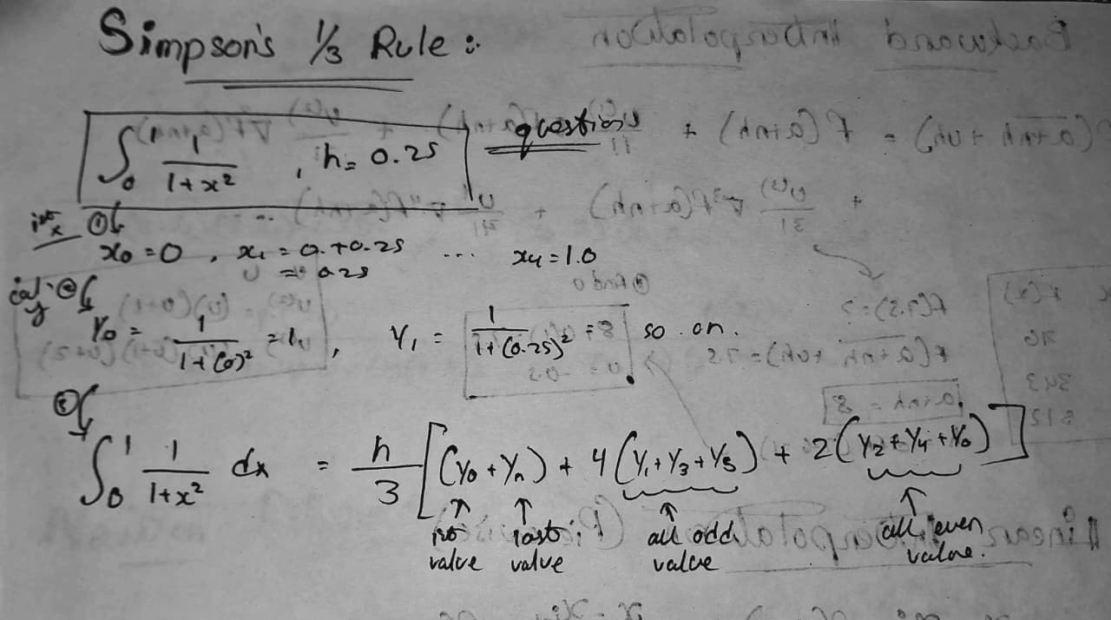
b) What is extrapolation, and how is it different from interpolation?
Extrapolation is the process of estimating the value of a function outside the given range of known data points.
Eg, if values are known for $x=1,2,3,4$and you estimate at $x=5$, it is extrapolation.
Extrapolation estimates values outside the range of given data, whereas interpolation estimates values within the given data range.
Extrapolation is generally less accurate because it predicts beyond known points, while interpolation is more reliable since it uses values between known data points.
C . Define relative error with a formula.
Relative Error is the ratio of the absolute error to the true (exact) value. It indicates how large the error is compared to the correct value.
$$\text{Relative Error}=\frac{∣\text{True Value}-\text{Approximate Value}∣}{∣\text{True Value}∣}$$

D What is meant by significant digits in numerical method?
Significant digits (or significant figures) in Numerical Methods refer to the number of digits in a number that contribute to its accuracy and precision.
Eg . 123 → 3 significant digits
  - 3 significant digits (leading zeros are not counted)
E. What is the basic idea behind the bisection method?
The Bisection Method is a numerical technique used to find the root of an equation $f(x)=0$.
works by repeatedly dividing an interval into two halves and selecting the subinterval where the sign change occurs until the root is approximated with desired accuracy.
F What is the purpose of interpolation in numerical analysis?
Interpolation is used to estimate the unknown value of a function at a point within the range of known data points.
Main Purposes
- Estimating Missing Values
- Data Approximation
- Simplifying Calculations
G .Determine the number of significant digits from following given number 93.20, 6.00004, 2.54103,14.10223.
93.20 → 4 significant digits
6.00004 → 6 significant digits
2.54103 → 6 significant digits
14.10223 → 7 significant digits
H What is the formula of Newton-Raphson method?
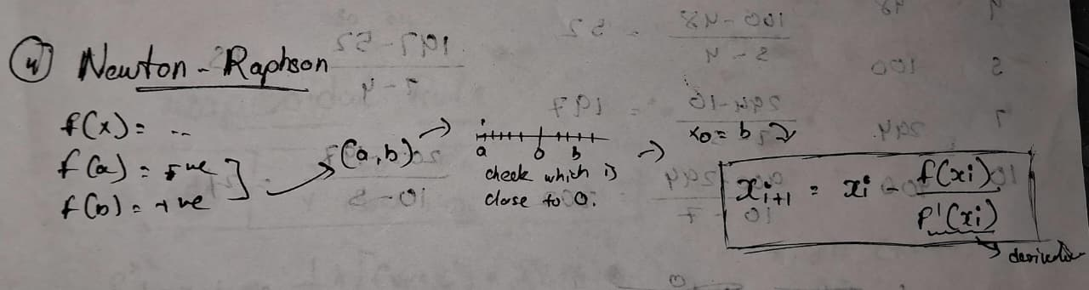
Explanation of Terms
- $x_{i}$= current approximation
- $x_{i+1}$= next (improved) approximation
- $f(x_{i})$= value of function at $x_{i}$
- $f^{'}(x_{i})$= derivative of the function at $x_{i}$

I What is Truncation error?
Truncation error is the error that occurs when an infinite process is approximated by a finite number of steps in numerical methods.
Truncation Error=Exact Value−Approximate Value
J Which rules are derive from newton cotes formula?
The main rules derived from Newton–Cotes formulas are:
- Trapezoidal Rule
- Simpson’s 1/3 Rule
- Simpson’s 3/8 Rule
- Boole’s Rule

A How does the Runge-Kutta method improve over the Euler method in solving ordinary differential equations?
The Runge–Kutta method improves over the Euler method by providing higher accuracy, lower error, and better stability through the use of multiple slope evaluations within each step.
B Write 2’s complement of (29)₁₀
Step 1: Convert (29)₁₀ to Binary
$${29}_{10}={11101}_{2}$$
Step 2: Represent in 8-bit Form
$$00011101$$
Step 3: Find 1’s Complement (Invert Bits)
$$11100010$$
Step 4: Add 1 to Get 2’s Complement
$$11100010+1=11100011$$
Final Answer
$$\text{2’s complement of }(29)_{10}=11100011$$

Explain the difference between round-off error and truncation-error.
Basis | Round-off Error | Truncation Error
Definition | Error due to limited number of digits in representation of numbers | Error due to approximating an infinite process by a finite process
Cause | Rounding numbers during calculations | Cutting off terms in series or numerical methods
Source | Computer representation (finite precision) | Mathematical approximation
Occurs In | Floating-point arithmetic operations | Numerical methods (integration, differentiation, series)
Nature | Depends on number of digits retained | Depends on number of terms or step size used
Example | ( \pi = 3.14 ) instead of 3.141592… | Using few terms in Taylor series
Control Method | Increase number of significant digits | Use more terms or smaller step size
Error Type | Accumulated over many operations | Systematic and predictable

